CURRICULUM VITAE
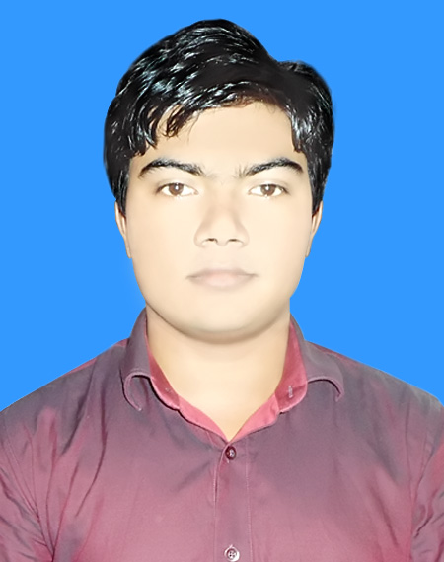

PHOTO
MD. AYUB ALI
C/O: Md. Majibar Rahman
Vill: Satny, P.O: Gunahar (5880)
P.S: Dupchanchia, Dist: Bogra
Cell: +8801737-625434
E-mail: rainbownetworkbd@gmail.com

- Educational Qualification:

Diploma In Engineering:
- Institution Name : Bangladesh Institute Of Information Tecnology
(BIIT),Bogra.
- Board : Technical Board
- Group : Electrical
- Passing Year : 2015 (4 years)
- Result (GPA) : (3.12 Out of 4.00)
Secondary School Certificate (S.S.C):
- Institution Name : Dupchanchia Pilot High School
- Board : Rajshahi
- Group : Science
- Passing Year : 2011
- Result (GPA) : (3.69 Out of 5.00)

- Personal Information:
Name : Md. Ayub Ali
Father’s Name : Md. Majibar Rahman
Mother’s Name : Mst. Akter Parvin
Present Address : C/O Md. Majibar Rahman
Vill: Satny, P.O: Gunahar (5880)
P.S: Dupchanchia, Dist: Bogra
Permanent Address : C/O Md. Majibar Rahman
Vill: Satny, P.O: Gunahar (5880)
P.S: Dupchanchia, Dist: Bogra
Date of Birth : 18th January, 1996
Sex : Male
Marital Status : Unmarried
Religion : Islam
Nationality : Bangladeshi
Blood Group : A^{+(ve)}
National ID No. : 19941013354000171
Height : 5 Feet 4 Inch
Weight : 69 Kg.

Date: Signature

